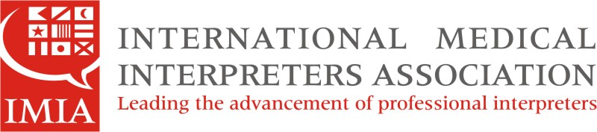

IMIA Colorado Members Agenda
Submitted by Geri McClymont, CO Chapter Secretary

Conference Call
June 6, 2014
6pm – 7pm

Participants: Rose Culley, Cynthia Hermosillo, Esther Soto, Delia Chavez, Nelly Berg, Geri
McClymont

Topics:

- Welcome

- IMIA information: The IMIA is a US-based international organization committed to the advancement of medical interpreters as the best practice for equitable language access to health care for linguistically diverse patients. Founded in 1986 and with over 2,000 members, the IMIA is the oldest and largest medical interpreters association in the nation, providing interpreting services in over 70 languages. Membership is open to those interested in medical interpreting and language access; there are many opportunities to volunteer within IMIA.

- IMIA international news: Upcoming events:
Symposia Oct. 3-5, 2014 in Little Rock, Arkansas on Education, Certification and Employment
Webinar June 20, 2014 on Social Media and the Medical/Healthcare Interpreter, presented by Lizbeth Odfalk, Public Relations Committee Chair

- IMIA Colorado Chapter news:
We are planning a meeting in Colorado Springs in August; stay tuned for more info; please contact Geri, CO Chapter Secretary if you would like to volunteer. cosecretary@imiaweb.org
We are considering a happy hour/coffee break in Denver once a month as a way to gather in a professional manner with other interpreters; please send suggestions or comments to Geri, CO Chapter Secretary.

- IMIA Colorado Dept. of Health collaboration regarding Interpreters Education: we will have more info at our mtg. in August.

- Questions and Answers:
Participants shared topics they would like to see addressed in future meetings via conference call. These included further training in medical terminology and training for the NBCMI exams.
Per a participant suggestion, a chain email will be created and sent out to IMIA CO Chapter members and non members to remind them about the upcoming symposia in Little Rock, Arkansas and to help coordinate travel and hotel stay for those interested.

