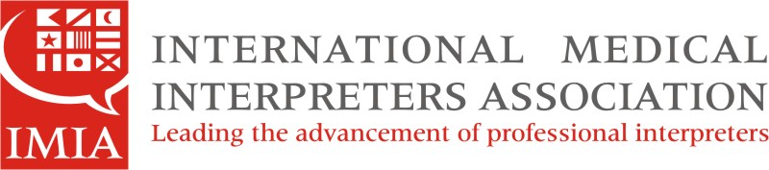

IMIA Colorado Conference Call Minutes
May 2, 2014
Submitted by Geri McClymont, IMIA Colorado Secretary

Participants: Nelly Berg, Dr. Lizbeth Mendoza, Martha Castillo, Geri McClymont
Topics:

- Updates, by Nelly Berg, IMIA Colorado Chair

- Conference calls are open to IMIA members and non-members; we encourage non-members to become IMIA members.
- The CO IMIA Chapter currently has 22 active members.
- IMIA headquarters is in Salem, MA, and is the oldest international medical interpreter association in the nation.
- Next webinar is on May 16 and will focus on Minority Languages (Increasing Access and Opportunities); webinar is free to IMIA members! For further info, see the IMIA website, under Events (Lifelong Learning Webinars).
- This year’s IMIA Symposium will be held in Arkansas on Oct. 3-5 (register before August to avoid higher fees). For further info, see the IMIA website, under EVENTS link.
- CO Dept. of Health has been collaborating with IMIA since July of last year. We are now planning events to support the medical interpreter profession. Stay tuned for more information during our next conference call.

- CMI Certification Process, by Nelly Berg, IMIA Colorado Chair and Dr. Lizbeth Mendoza, IMIA Colorado Vice Chair

- There are 3 ways to become a CMI: The National Association of the Deaf (NAD) in conjunction with the Registry of Interpreters for the Deaf, Inc. (RID) , NBCMI, and CCHI.

( continued on next page)

- We will ask if scholarships may be available in the future to help cover the certification fees.
- While details of the exams cannot be shared due to confidentiality agreements, participants who have taken the written and/or oral part of the certification exams shared general testing experiences as follows….
- Approximately 80% of items on the written portion of the CCHI exam were on medical interpreter code of ethics, with approximately 20% of items focusing on medical terminology; approximately 40% of items on NBCMI exam were on medical interpreter code of ethics, with approximately 60% of items focusing on medical terminology.
- Results for written exam are received immediately after completion of exam.

- Safety Tips when Interpreting Medication, by Dr. Lizbeth Mendoza, IMIA Colorado Vice Chair

- It is important for medical interpreters to be aware of the safety measures that are being established worldwide regarding medication use. Some sources of information were given to participants for self- study topics about medications in both English and Spanish.
- Due to current safety regulations, the generic names of medications are being used more than their brand names.
- While it is good to use the Spanish generic name for the medication you are interpreting, you MUST also use the English name. This is because the name written on the patient’s medication bottle will more than likely be written in English.

