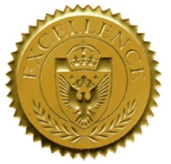
Commission for
Medical
Interpreter
Education
A Division of the IMIA

CMIE Accreditation enhances the quality, recognition, and competitiveness of your training program.
Stand out from the crowd. Get accredited.

For more information about CMIE Accreditation, go to:
http://www.imiaweb.org/education/accreditationprogram.asp

The CMIE Accreditation program consists of a full review process following professional accreditation best practices and procedures, such as a team of two auditors, a preliminary review, an onsite audit, and a final report with recommendations.

